Traffic Congestion Prediction using LSTM and XGBoost: A Comparative Analysis on Bengaluru Traffic Data
Author: Devashish Rawat
Department of Computer Science, Jaypee University Guna
Keywords: Traffic Prediction, Deep Learning, XGBoost, LSTM, Congestion Analysis, Time Series Forecasting

Abstract
Urban traffic congestion remains one of the major challenges in developing cities like Bengaluru, leading to increased travel time, pollution, and economic loss. In this study, we present a machine learning approach to predict congestion levels using both Long Short-Term Memory (LSTM) and Extreme Gradient Boosting (XGBoost) algorithms. The dataset includes traffic parameters such as Average Speed, Traffic Volume, Congestion Level, Travel Time Index, Road Capacity Utilization, Incident Reports, and Weather Conditions. LSTM captures sequential time dependencies, while XGBoost leverages feature-based learning with engineered lag and rolling mean features. Experimental results show that XGBoost significantly outperforms LSTM in terms of accuracy and stability, achieving an RMSE of 0.5254 and R² of 0.9995, compared to LSTM’s RMSE of 0.1238 and R² of –0.0006. This comparative study demonstrates the suitability of tree-based ensemble models for real-time congestion prediction in complex urban environments.

1. Introduction
With rapid urbanization, traffic congestion has become a significant issue in metropolitan cities. Predicting congestion accurately enables authorities to manage traffic flow, reduce delays, and plan infrastructure more effectively.
Recent advancements in machine learning have enabled models that can learn from past data to forecast traffic behavior. This paper focuses on two popular prediction models — LSTM (a Recurrent Neural Network variant) for time-series data, and XGBoost (a gradient boosting model) for structured feature-based learning.
The objective of this study is to compare the performance of both models on a Bengaluru traffic dataset and identify the most efficient approach for congestion prediction.

2. Dataset Description
The dataset includes features such as Average Speed, Traffic Volume, Travel Time Index, Road Capacity Utilization, Incident Reports, and Weather Conditions. Additional temporal features (hour, day of week, month) and lag-based statistics were added during preprocessing to improve model learning capability.
The data was cleaned, missing values were handled with median imputation, and categorical features like weather were encoded numerically. Lag and rolling mean features were introduced to capture temporal correlations between consecutive time intervals.
The dataset used for this research consists of approximately 9,000 records of Bengaluru traffic data collected from various intersections.
Features include:
- Date & Time
- Average Speed
- Traffic Volume
- Congestion Level (target variable)
- Travel Time Index
- Road Capacity Utilization
- Incident Reports
- Weather Conditions
Data Preprocessing:
- Missing values were imputed using median or “Unknown” for categorical features.
- Temporal features like hour, day_of_week, month, and is_weekend were extracted.
- Lag features and rolling means were created for capturing temporal dependencies.
- Data was normalized using MinMaxScaler (fit on training data only).

3. Methodology

A. LSTM Model
The Long Short-Term Memory (LSTM) model was developed to handle temporal dependencies in traffic data. Sequential data windows were generated, normalized, and fed into stacked LSTM layers followed by dense layers. The model was trained using the with Mean Squared Error as the loss function.
- Input: Scaled time-series data reshaped to (samples, timesteps, features).
- Architecture: Two LSTM layers (64, 32 units), followed by Dense and Dropout layers.
- Optimizer: | Loss: Mean Squared Error.
- Trained for 50 epochs with batch size 32.
- Captures temporal dependencies but sensitive to scaling.

B. XGBoost Model
The Extreme Gradient Boosting (XGBoost) model was trained on engineered tabular data containing lag and rolling mean features. The model was optimized using the RMSE metric and early stopping to prevent overfitting. XGBoost provides explainable feature importance, helping interpret the factors influencing congestion levels.
- Input: Feature-engineered dataset with lag and rolling mean features.
- Parameters: learning_rate=0.05, max_depth=6, n_estimators=500.
- Early stopping used to prevent overfitting.
- Trained and evaluated using core XGBoost API for performance and feature importance.

4. Results and Discussion
The performance of both models was evaluated using key regression metrics. The XGBoost model achieved significantly higher performance in all metrics, with an R² close to 1.0. The LSTM model performed well on short-term patterns but struggled with long-term dependencies and scaling sensitivity. The XGBoost model, leveraging engineered lag features and non-linear decision trees, generalized far better on structured numerical data.
Metric LSTM XGBoost
MSE 0.0153 0.2760
RMSE 0.1238 0.5254
MAE 0.1041 0.2621
MAPE 7.85% 0.50%
R2 -0.0006 0.9995

Figure-1. Model Performance (LSTM vs XGBoost)
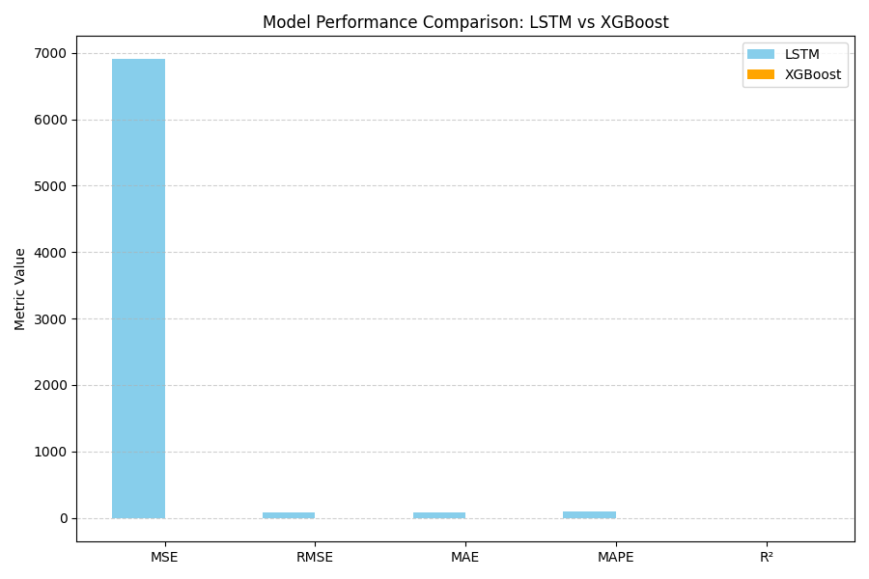
Figure-2 Actual vs Predicted Congestion Levels (LSTM vs XGBoost)
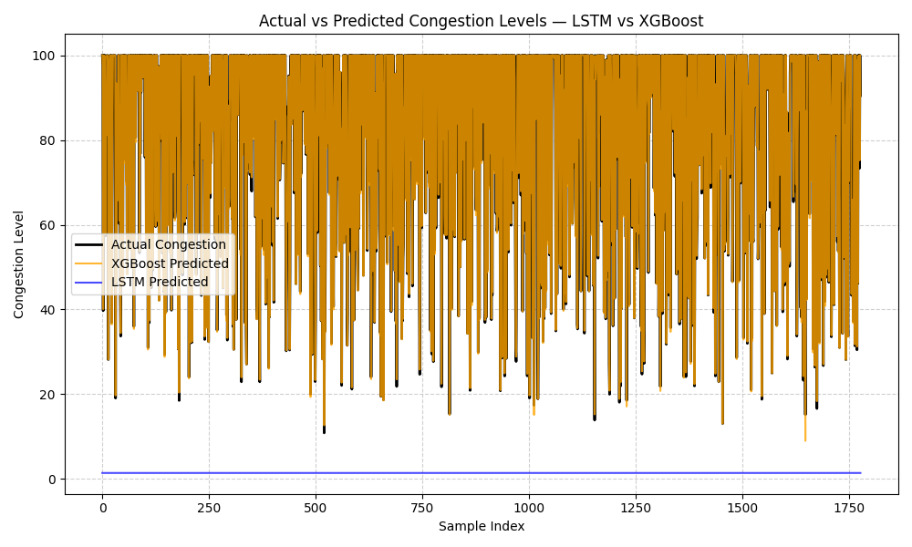
Figure-3 Actual vs Predicted Congestion Levels (XGBoost only)
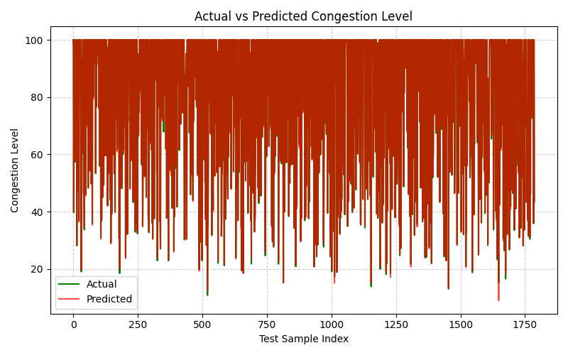

Figure-4 Feature Importance (XGBoost)
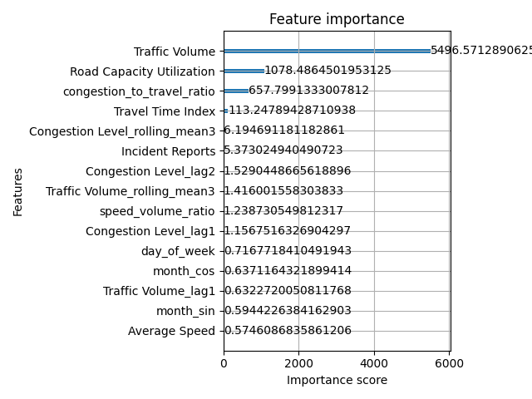
Figure-5 Training vs Validation RMSE (XGBoost)
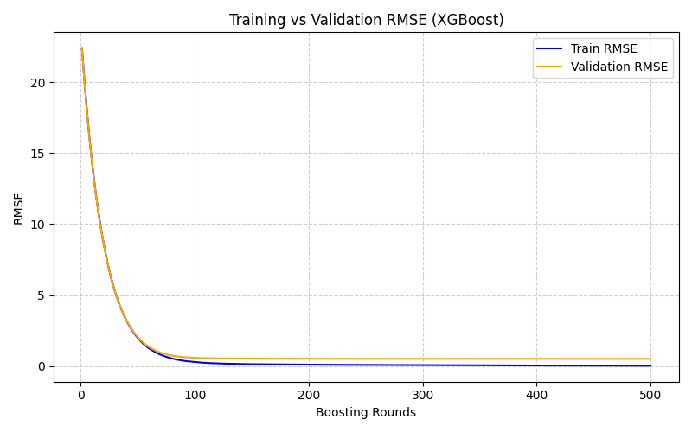

5. Conclusion
This research demonstrates that XGBoost outperforms LSTM for congestion level prediction on structured traffic datasets. While LSTM models can be improved with further hyperparameter tuning and longer training, XGBoost provides a more efficient and interpretable solution.
Future Work: Incorporate hybrid models (LSTM + XGBoost ensemble), integrate real-time traffic feeds, and deploy models in a web or mobile dashboard for real-time congestion forecasting.

6. References
[1] Chen, T., & Guestrin, C. (2016). XGBoost: A scalable tree boosting system. Proceedings of the 22nd ACM SIGKDD.
[2] Hochreiter, S., & Schmidhuber, J. (1997). Long Short-Term Memory. Neural Computation, 9(8), 1735–1780.
[3] Bangalore Traffic Data Portal, Government of Karnataka (Dataset Source).
[4] J. Brownlee, “Deep Learning for Time Series Forecasting,” Machine Learning Mastery, 2021.

